MTA “NEMETI70” conference
07-17. September 2012
HOTEL RESERVATION FORM
ibis Budapest Centrum
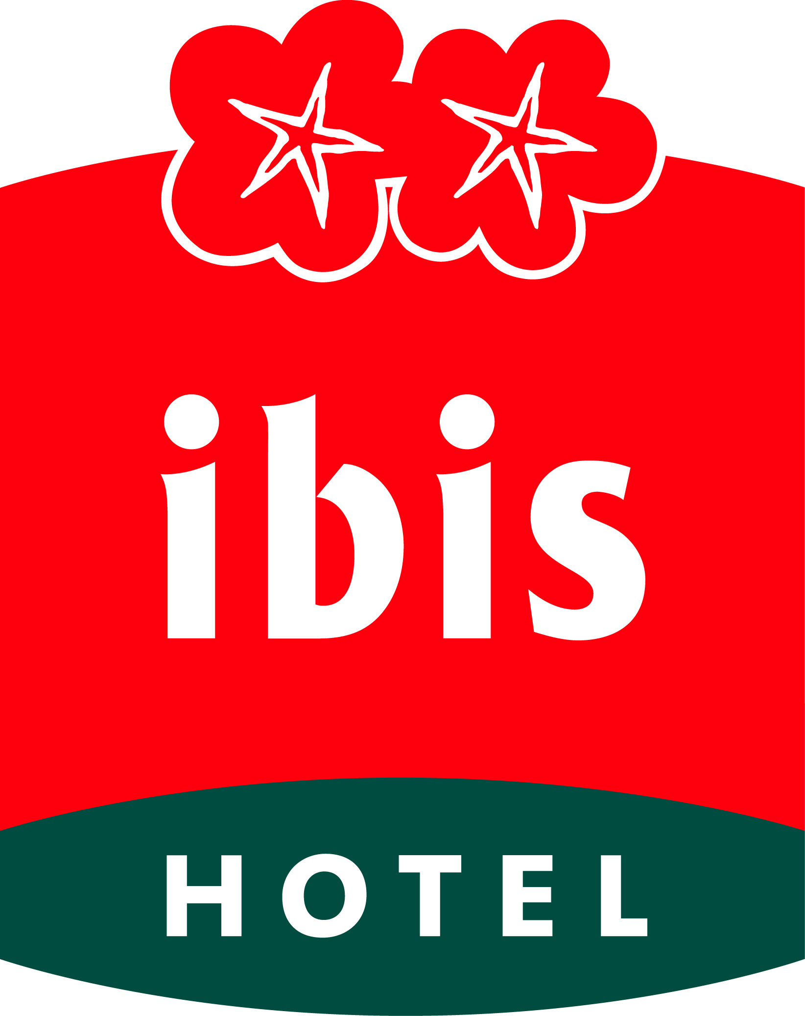

Please complete in BLOCK CAPITALS and return by fax or mail directly to:

ibis Budapest Centrum  Ráday u. 6  H- 1092 Budapest  Tel: +36 1 456 4100  Fax: +36 1 456 4116  E-mail: h2078@accor.com | RATE PER NIGHT  Breakfast and taxes included
 | BEDROOM TYPE |  |  | SINGLE |  | DOUBLE
 | Standard Room |  |  | € 65 |  | € 70
 | Non smoking room |  | Smoking room

Date of Arrival: Hour: Date of Departure: Hour:
Family name: First name:
Title/Profession: Organisation/Company:
Mailing address:

Country:
Telephone: + Fax: +
E-mail:
Accompanied by (name):
Reservation guaranteed by my credit card:
q Mastercard / Eurocard q American Express q Visa q Diners

Cardholder Name

Card Number

Expiry date
Please note:
- To take advantage of these rates, please use ONLY this reservation form.
- The deadline date for reservations is 10th August 2012.
- Check in time is 14:00 / Check out 12:00
Cancellations Policy:
- I guarantee this room reservation with my credit card. I agree that in case of non-arrival, the all night’s room rate will be charged to my credit card, unless the reservation has been cancelled and the cancellation confirmed by fax 3 days before the arrival date.

- Date: ………………………………. Signature/authorization:………………………………

